Software Project Management Plan (SPMP) for SmartCar Project

*Baseline version 0.1*

*Issued on : July 27, 2014*

Issued by :

Roberto

Ryant

Ryan

Steven

Issued for : Sutrisno

# Signature

The following signature indicates approval of the enclosed Software Project Management Plan.

___________________________________________

Sutrisno

# Change History

|  |  |  |  |
| --- | --- | --- | --- |
| **Version** | **Date** | **Author** | **Changes** |
| 0.1 | August 27, 2014 | Group | initial version |
|  |  |  |  |

# Preface

This document delivers the proposed plan to be taken by our group to meet the needs of software to complete a OOP Project. In order to do so, we as a group will make a program using java programing language in various platforms (Notepad++ & Eclipse) to make our project ideas come to fruition.

This SPMP is intended to be used for the making of smart car project. So the lecturer will know our project and how our group make the project to a reality.

***Important Notes for Soft-copy Viewing***

This copy of document are delivered in docx format, so please be aware that you must have Microsoft Office installed to your computer especially Microsoft Word if you want to see this document.

# Table of Contents

Contents

Signature i

Change History ii

Preface iii

Table of Contents iv

List of Figures v

List of Tables vi

Chapter 1 1

1.1 Project Overview 1

1.1.1Purpose, Scope, and Objectives 1

1.1.2 Assumptions and Constraints 1

1.1.3 Project Deliverables 2

Chapter 2 3

2.1 Software Process Model 3

2.2 External Intefaces 3

2.3 Internal Structure 5

2.4 Roles and Responsibilities 5

2.5 Tools and Techniques 6

2.5.1. Development Techniques 6

2.5.2. Tools 7

Chapter 3 7

3.1 Work Activities 7

3.2 Activity Network 8

# List of Figures

# List of Tables

# Chapter 1

**INTRODUCTION**

## 1.1 Project Overview

This project consists of the component of a smart car and the environment which include:

* Simulation (Main Class)
* Car
* HUD (Heads-up Display)
* Sensor
* Machine
* Obstacle
* Tire
* Road

### 1.1.1 Purpose, Scope, and Objectives

The purpose of this project is to simulate how a Smart Car works in a real life situation for example how the car response to an obstacle, how was the tire condition, how the car sensor worked, etc.

The scope in this project are how the car react to something in front of the car with the sensor that are available in the car or to know what are the condition on the car surroundings.

The objectives of the project are mentioned as follows :

* Complete the project by the due date
* Meet all the requirements that are mentioned in the project documentation.

### 1.1.2 Assumptions and Constraints

Here is the list of all assumptions that are made :

* GUI is not the top priority
* Using International System of Units
* Car will move based on accelerated linear motion rule.
* As the speed goes up, then the temperature goes up
* If the car run too long and the tire hold the car weight, then the pressure on the tire will decrease.
* Car will slow down if the tire pressure less than 10% of its initial position
* Car will turn, if the car close with a obstacle or on certain speed
* Track always straight
* Lights will on at night.
* If there are many obstacle, obstacle will be filled at the same row
* Car will stop if the tire pressure is empty
* Carl light intensity is 100 candela

Here is the list of all constraints that are made :

* Budget
  + $ 0
* Time
  + 2 months

### 1.1.3 Project Deliverables

The items that we want to deliver are:

* Software program, along with its environment and supporting libraries.
* Software documentation
  + Installation documentation
  + End-user documentation
* Installation of software program along with its environment and supporting libraries.
* Project documentation
  + Software Project Management Plan (SPMP)
  + Software Requirement Specification (SRS)
  + Software Design Description (SDD)
  + Software Test Documentation (STD)
  + Software Test Plan (STP)
  + Software Quality Assurance Plan (SQAP)
  + Software Configuration Management Plan (SCMP)

# Chapter 2

**PROJECT ORGANIZATION**

## 2.1 Software Process Model

*Use this part to state what software process model that you choose. Mention any consideration that you put in choosing it. Remember, whatever software process model you choose here should affect the whole project’s run.*

## 2.2 External Intefaces

*Use this part to mention all project participants who aren’t necessarily in your team (hence external) and yet take parts in larger scale of your project. In order to make it clearer, you can provide this information using a chart. Following is an example of the chart.1*

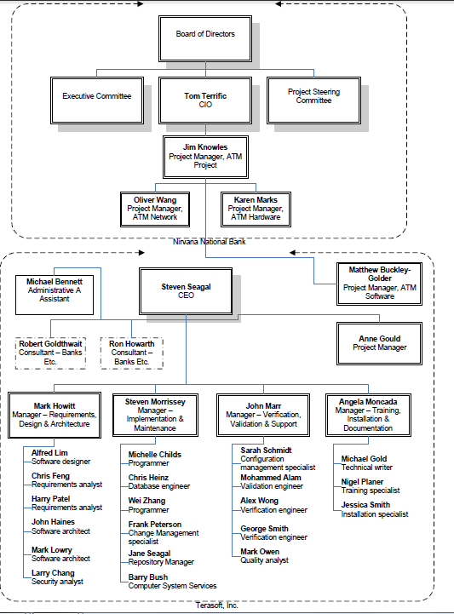

## 2.3 Internal Structure

*Use this part to mention who are involved in your team as project participants. Following is an example of a chart that gives that information.*

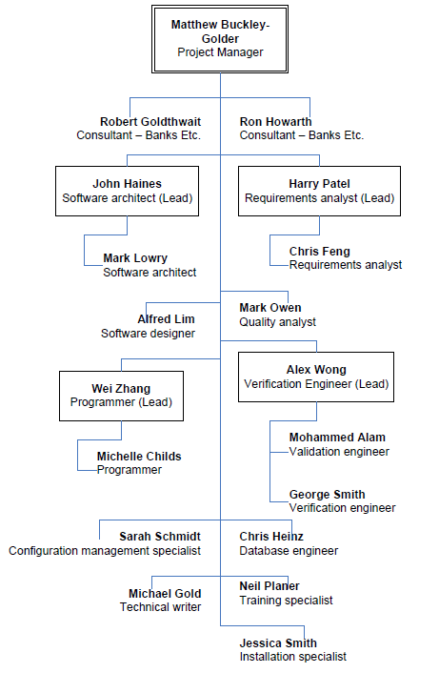

## 2.4 Roles and Responsibilities

*In general, this part gives information about who will be responsible in doing tasks or deliverables that are needed. As a suggestion, you can use Responsibility Assignment Matrix (RAM). Definition about RAM can be found online or on literature. Following is an example of how RAM looks like. As a side note, you are required to have at least 25 WBS (main WBS), therefore you should at least have 25 ID’s in this table. Every individual that is mentioned in your internal structure (2.3.) must be included in this table as well.*

|  |  |  |  |  |  |  |  |  |
| --- | --- | --- | --- | --- | --- | --- | --- | --- |
| ID | WBS | Deliverables | CEO | Project Manager | Requirement Analyst 1 (Lead) | Requirement Analyst 2 | Programmer 1 (Lead) | … |
|  | 1 | Blabla Project |  |  |  |  |  |  |
|  | 1.1 | Software Lifecycle Model Process |  |  |  |  |  |  |
| 1 | 1.1.1 | Select project model |  | L |  |  |  | … |
| … | … | … | … | … | … | … | … | … |
|  | 1.2.4 | Plan Project Management |  |  |  |  |  |  |
| 13 | 1.2.4.1 | Create baseline WBS |  | L | C |  | C | … |
| … | … | … | … | … | … | … | … | … |
|  | **Key** |  |  |  |  |  |  |  |
|  | A | Approval | 21 | 10 | … | … | … | … |
|  | L | Lead | 4 | 2 | … | … | … | … |
|  | S | Secondary | 0 | 4 | … | … | … | … |
|  | C | Contributor | 0 | … | … | … | … | … |
|  | R | Reviewer | 2 | … | … | … | … | … |

## 2.5 Tools and Techniques

2.5.1. Development Techniques

The project uses eclipse as a program that our group uses to make this project and the techniques that our group will use are Object Oriented techniques such as inheritance, polymorphism, class, encapsulation, etc.

### 2.5.2. Tools

Operating System

* Microsoft Windows 7
* Microsoft Windows 8

Project Management

* Notepad++
* Eclipse

Documentation

* Microsoft Word 2010

# Chapter 3

**PROJECT MANAGEMENT PLAN**

## 3.1 Work Activities

29-5-2014 : Project Start (A)

2-6-2014 : Task distribution for each group member

14-6-2014 : Class Diagram production

20-6-2014 : Collecting data from each group member

21-6-2014 : Report production

26-6-2014 : Report Submission.

1-7-2014 : Coding from Class Diagram for each group member.

18-7-2014 : Coding Submission from group member

19-7-2014 : Project Testing

21-7-2014 : Coding Revision

29-7-2014 : Project Submission

## 3.2 Activity Network

*Using dependencies that you have from Work Activities above, you are required to make an activity network here. Example of how activity network looks like can be found at TM.*